Monthly View as at 28 February 2023

Overview
The key theme for February was positive economic data. Any other time that would be good for markets but as each central bank around the world grapples with inflation, data showing a slowing economy is what each is looking for.
In January share market investors jumped the gun in thinking that the US Federal Reserve (the Fed) would pivot from interest rate increases to talk of pausing future interest rate increases or even cutting later in the year or 2024. In February the Fed increased interest rates by 0.25% and guided that there would need to be “ongoing increases”. The Bank of England (BOE) increased rates 0.50% but guided that future rate rises were conditional on economic data.
Later in February any hope for the “pivot” disappeared as a series of stronger US economic data was released. The market was caught off guard and we saw share markets weaken into the end of the month. Returns year to date are still positive but it took some wind out of the sails of a fully-fledged share market recovery.
On the positive side, these interest rate increases mean investors are now being rewarded for holding relatively low risk bond investments, with the additional possibility of stronger share market returns once we see inflation levels falling.
Share markets will recover and typically the recovery will occur before the economic data shows this improvement. The chart below provides a good illustration of how industrial production, a gauge of demand, continues to weaken while the share market is rising, before both the production and share market index show the economy growing.

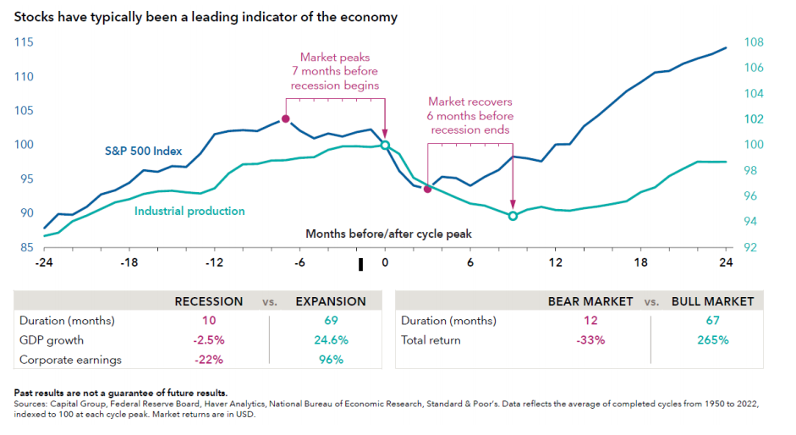

Historically, recessions have on average been for 10 months while expansions have lasted for 69 months. Growth and earnings are larger for longer, translating into the attractive total returns in a bull vs. bear market.

Economies remain resilient
Central banks’ efforts to tame inflation by tightening monetary policy are essentially an attempt to reduce the prevailing level of economic demand. Activity level measures are mixed in this regard. The US Institute of Supply Management measures activity both in the services and manufacturing sectors. The ISM index for services was 55.1 in February, which indicates this segment of the economy was in expansion mode. In contrast the manufacturing index recorded 47.7 in February, slightly better than January but indicating contraction in manufacturing. The services sector dominates most economies, for example contributing 77.6% of US GDP.

China’s shift in COVID management and subsequent reopening of the economy has clearly had a positive impact on activity there. Manufacturing in China was also in expansionary mode but not to the degree of services at 51.6 in February. The level of activity is China is of global significance, ranging from Australian resources demand to French luxury goods. Activity levels are also reflected in employment statistics.
The United States headlines have highlighted large layoffs in technology companies from Meta (11,000) to Amazon (18,000). However, US Non-Farm Payrolls have been strong with 517,000 jobs created in January, and the ratio of job openings to job seekers is estimated at 2 to 1. Consumer demand and remuneration remain strong as a consequence and represent a hurdle to the inflation fight.

New Zealand Share Market
For February the New Zealand share market fell 0.60% after rising over 4% in January. In February there were a number of companies providing an update and guidance for the coming year. Broadly companies delivered revenue ahead of what the market expected but costs pressures meant net profits were below expectations. Rising costs from wages and materials was a common theme.
The big news was the almost $1 billion capital raise by Ryman Healthcare Ltd. The company is looking to strengthen its balance sheet through the repayment of debt and provide some capital for future growth. The retirement sector saw weakness across the board and was one of the weakest performers for the month.
In February the Reserve Bank of New Zealand (RBNZ) had a difficult decision to make in the wake of the floods in Auckland and then the Gisborne/Hawkes Bay region. Economic data had been strong showing inflation has been persistent but on the other hand the RBNZ had to weigh up the impact of higher interest rates on parts of the economy already reeling from storm damage and disruption to livelihoods. From a long-term perspective taming inflation has to occur and raising the Official Cash Rate by 0.50% was most probably a difficult but right call.

Australian Share Market
The Australian share market fell over February and was down 2.7%. The Australian economy is showing signs of cooling and inflation eased in January. Markets are expecting further interest rate increases but are now forecasting this to occur in increments of 0.25% as further data confirms inflation is tracking towards the Reserve Bank of Australia’s target range.
Reporting season is nearing the end and the consistent theme is revenue figures that were in line with market expectations, but earnings lower. This shows growth continues through higher sales, but companies are finding it increasingly difficult to pass on rising input costs. As always there are sectors that will benefit as consumers change their behaviour and spending patterns, China continues to catch up infrastructure spend and with borders reopening the movement of people to Australia will see increasing demand in retail and housing.
Global Share Markets
The European region once again outperformed the US markets as the large tech companies of the US struggled to hold on to their gains from January. Investor sentiment changed as the Fed reiterated its stance that interest rates will rise and may have to be higher for longer to bring inflation back to the target range. The Fed’s preferred inflation gauge, the core Personal Consumption Expenditure (PCE) price index, unexpectedly accelerated in January and consumer spending rose.
Fourth quarter earnings results in the United States have almost all been announced, (over 90% of companies have reported). Revenue outcomes are more positive than earnings outcomes, suggesting cost pressures are material. Valuations of the S&P500 are consistent with long-term averages. Financial markets are forward-looking though and we can expect earnings to recover in the second half of 2023.
Europe had another positive month and has had some of the best performing markets over one year. Recent performance has been in part driven by the outlook improving from what investors feared for in 2022. The fear of economic weakness stemming from high gas prices diminished. Inflation remains a concern which is leading to higher interest rates, which is generally beneficial for banks. Many of the European indices are resource and financial sector heavy and this explains a significant portion of the performance over the last 12 months.

Summary
Inflation, and bringing this to within each central bank’s target range, continues to be the key theme. In general, the data shows economies continue to grow and the cost of production increasing. Central banks are resolute in their commitment to increasing rates until there is evidence that the higher interest rates are slowing the economy. A pivot in the central bank’s position on interest rates will be a catalyst for markets to rise. Fixed interest is now being rewarded and an investor can receive yields over 6% with the possibility of future interest rate cuts once inflation has been tamed.

Share markets are forward looking so the market will react before the data shows the economy growing. As such having exposure to growth assets is advised but being selective in how you gain that exposure will be the key. High growth companies continue to struggle but those that are able to pass on cost increases and pay a sustainable dividend, should prosper in a slowing environment.
Focusing on your long-term goals while acknowledging that in the short-term, returns may be volatile, should reward investors.

Indices for Key Markets
As at 28 February 2023 | 1 Month | 3 Months | 1 Year | 3 Years p.a. | 5 Years p.a.
S&P/NZX 50 Index | -0.6% | 3.0% | 0.1% | 2.5% | 8.1%
S&P/ASX 200 Accumulation Index (AUD) | -2.4% | 0.3% | 7.2% | 7.9% | 7.9%
MSCI ACWI Index (Local Currency) | -1.9% | -0.5% | -5.5% | 9.7% | 7.1%
MSCI ACWI Index (NZD) | 1.1% | 0.5% | 0.0% | 9.0% | 9.1%
S&P/NZX 90 Day bank bill Total Return | 0.4% | 1.1% | 2.8% | 1.3% | 1.5%

Additional information & disclaimer:
This report is for information purposes only. It does not take into account your investment needs or personal circumstances, so it is not intended to be viewed as personalised
investment or financial advice. If you require financial advice, you should always speak to your financial adviser.
The price, value and income derived from investments may fluctuate because values can go down as well as up and investors may get back less than originally invested.
Past performance is not indicative of future results and no representation or warranty, express or implied, is made regarding future performance.
This report has been prepared from published information and other sources believed to be reliable and accurate.
While every effort has been made to ensure accuracy Thorner Investment Services Ltd, JMI Wealth nor any person involved in this publication accept any liability for any errors
or omissions nor accepts any liability for loss or damage as a result of any reliance on the information presented.
Disclosure statements are available on request and free of charge.

